Project Design Phase
Solution Architecture

Date | 30 September 2026
Team ID | SWTID-2026-6606
Project Name | AI FitTrack API
Maximum Marks | 4 Marks

Solution Architecture:
Solution architecture is a complex process – with many sub-processes – that bridges the gap between business problems and technology solutions. Its goals are to:
- Find the best tech solution to solve existing business problems.
- Describe the structure, characteristics, behavior, and other aspects of the software to project stakeholders.
- Define features, development phases, and solution requirements.
- Provide specifications according to which the solution is defined, managed, and delivered.

Example - Solution Architecture Diagram:


Figure 1: Architecture and data flow of the voice patient diary sample application
Reference: https://aws.amazon.com/blogs/industries/voice-applications-in-clinical-research-powered-by-ai-on-aws-part-1-architecture-and-design-considerations/
Solution Architecture Diagram – AI FitTrack API:
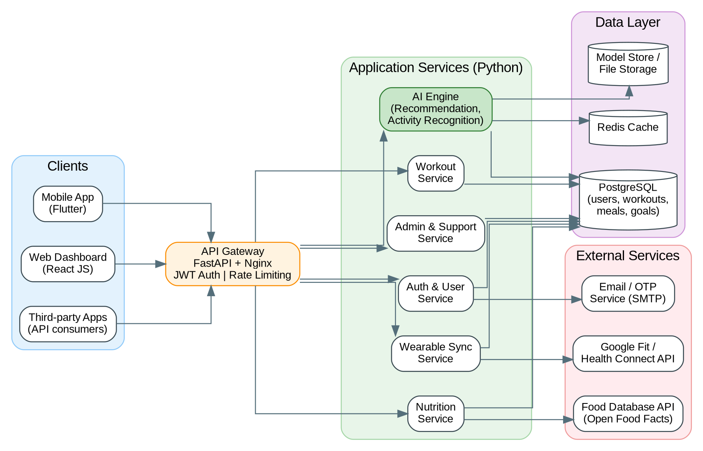
Figure 2: Architecture and data flow of AI FitTrack API
How the solution works:
• Mobile app, web dashboard and third-party apps call the REST API over HTTPS. The API gateway (FastAPI behind Nginx) checks the JWT token or API key and applies rate limits.
• Requests are routed to modular services: Auth & User, Workout, Nutrition, Wearable Sync, AI Engine, and Admin & Support.
• Users, workouts, meals and goals are stored in PostgreSQL. Redis caches frequent results such as dashboards and recommendations.
• The Wearable Sync service pulls steps and heart-rate data from Google Fit / Health Connect. The Nutrition service looks up food values from the Open Food Facts API, and the Auth service sends confirmation emails and OTPs.
• The AI Engine reads the user's profile and history, loads trained models from the model store, and returns a workout plan, calorie and macro targets and detected activities.
• The whole system is packaged in Docker containers and deployed on a cloud server with monitoring and logging.

